Updating Java Security Settings after updating to version 7 update 51 or later
On Windows 7 and 8 computers select the Windows key on your keyboard or from the Start screen in Windows 8 start typing “Java” and you should see “Configure Java” in the selection list. Select it to open the Java Control Panel. For Window XP open Control Panel and select Java or Java (32-bit).
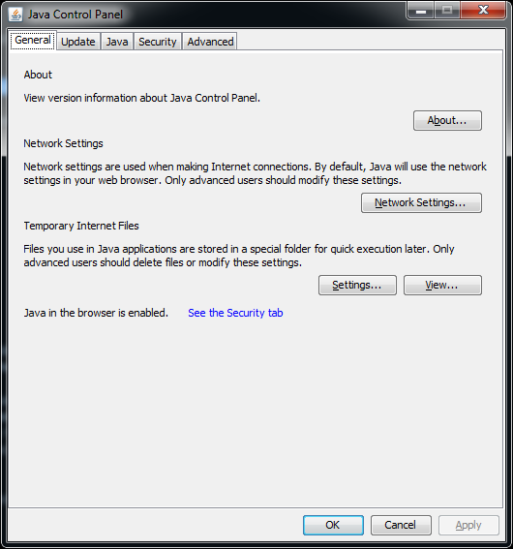

In the Java Control Panel select the Security tab.
Note: if you are on a Java version earlier that 7 update 51 you will not see the Exception Site List and this tutorial does not apply to you.
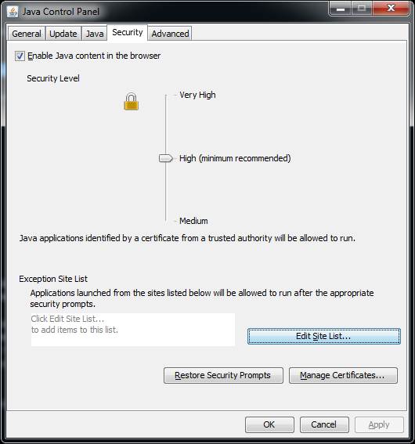

For access to all applications managed by HCI Research Informatics you need to add the following servers to the Site Exception List:
https://hci-bio-app.hci.utah.edu/

You can do this by clicking the Edit Site List button.
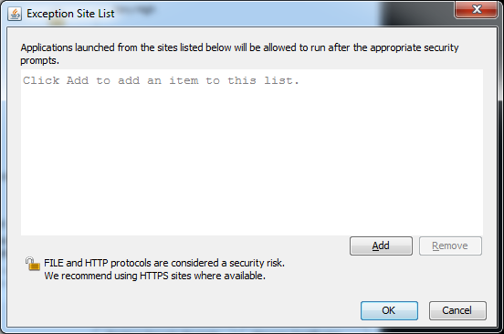
Click the add button to begin adding sites.
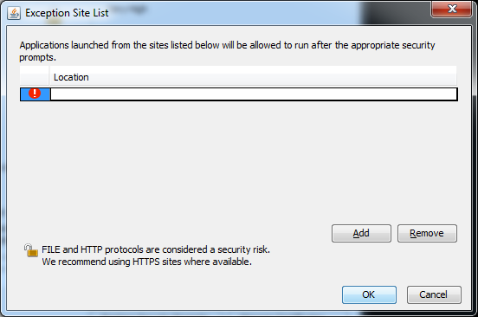
Add the sites shown above one at a time by clicking the Add button after entering each site. You can copy and paste the site addresses from this document. After adding a site click add to get a new row.
After adding the sites your list should look like this:
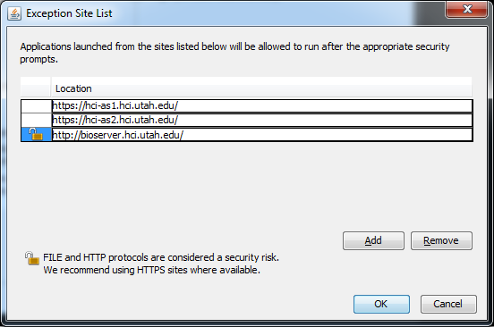

Click OK and you will get a Security Warning.
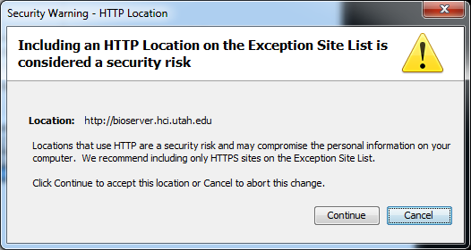

Click Continue and you are returned to the Security tab which now should look like this with the sites added:
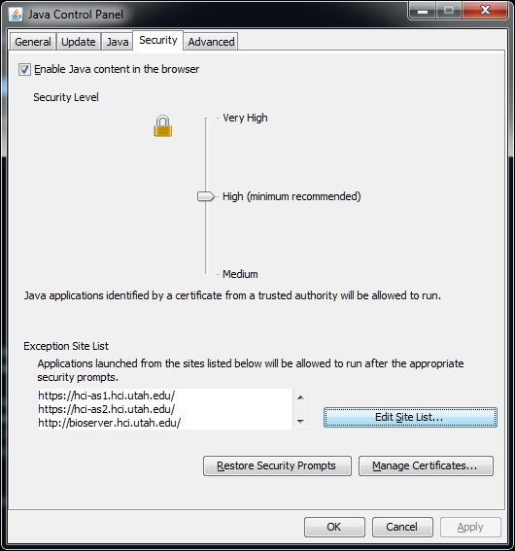
Click OK to exit the Java Control Panel.
HCI applications using Java in your browser should now run.

